ABSTRACT

The optimization of public transportation systems is a critical aspect of modern urban planning and sustainable mobility. This abstractprovides an overview of the key elements involved in public transportation optimization, which include the integration of advanced technologies, data-driven decision-making, and a focus on improving efficiency and accessibility. By leveraging Internet of Things (IoT) devices, GPS tracking, and sensor technologies, public transportation systems can enhance route planning, reduce traffic congestion, and minimize environmental impact. Moreover, the application of artificial intelligence and smart city principles allows for real-time data analysis, predictive maintenance, and passenger-centric services. These advancements not only make public transportation more appealing and efficient but also contribute to creating cleaner, more accessible, and interconnected urban environments. This abstract underscores the importance of continued development in the field of public transportation optimization to address the challenges of urbanization and provide sustain
TABLE OF CONTENTS

CHAPTER NO TITLE PAGE NO ABSTRACT i
1 INTRODUCTION 1

1.1 PUBLIC TRANSPORT OPTIMIZATION 1

1.2 NEED OF PUBLIC

TRANSPORT OPTIMIZATION 2

2 ARCHITECTURE OF PUBLIC

TRANSPORT OPTIMIZATION 3

2.1 BLOCK DIAGRAM OF PUBLIC TRANSPORT OPTIMIZATION 3
3 PROPOSED METHODOLOGY 4

3.1 HARDWARE DESCRIPTION 4

3.1.1 ESP32 4

3.1.2 IR RECEIVER 5

3.1.3 GPS TRACKER 6

3.1.4 ESP32-MINI-1 MODULE 7

3.2 SOFTWARE DESCRIPTION 8

3.2.1 ARDUINO IDE 8

3.2.2 NODE RED 9

4 CIRCUIT OF THE PROPOSED METHOD 10

4.1 WORKING 10

4.2 CODE 11

5 RESULT 14

5.1 ADVANTAGES 15

5.2 LIMITATIONS 16

5.3 APPLICATIONS 16

6 FUTURE SCOPE 17

6.1 CONCLUSION 17
CHAPTER-1

INTRODUCTION

PROJECT OVERVIEW

The project aims to leverage Internet of Things (IoT) technology to optimize and improve the efficiency of public transportation systems. By collecting and analyzing real-time data from various sources, this project seeks toenhance the overall quality of public transportation services, reduce congestion, minimize delays, and provide passengers with a more convenient and sustainablecommuting experience.

The project will be executed in phases, with an estimated timeline of 12-24 months, starting with a pilot program and gradually expanding to cover the entire public transportation network

Reduced travel times and improved service reliability. Enhanced passenger experience with real-time information. Reduced environmental impact and lower emissions. Data-driven decision-making for public transportation authorities. Improved cost-efficiency in transportation operations.

The project's success will be evaluated based on key performance indicators, including reduced travel times, improved passenger satisfaction, lower environmental impact, and cost savings for public transportation authorities.

1.1 PUBLIC TRANSPORTATION OPTIMIZATION

“Public Transportation Optimization in IoT Project” refers to an initiative that leverages Internet of Things (IoT) technology to enhance the efficiency and effectiveness of public transportation systems. This type of project focuses on using sensors, data analytics, and real-time information to improve various aspects of public transportation, such as bus, train, and subway services. The primary goal is to provide passengers with a more convenient and reliable commuting experience while optimizing the operation and management of publictransportation networks.

1.2 NEED OF PUBLIC TRANSPORTATION OPTIMIZATION

Public transportation optimization is essential to address the challenges of modern urban mobility. Key needs include the deployment of IoT sensors and devices to collect real-time data on vehicle locations and passenger counts, a robust communication infrastructure for seamless data transmission, and a centralized data processing system for efficient data analysis. Machine learning algorithms are crucial for route optimization, predictive maintenance, and data- driven decision-making. User-friendly interfaces like mobile applications and digital displays at transit stations are essential to provide real-time information to passengers. Security measures, privacy considerations, feedback mechanisms, and stakeholder collaboration are necessary for the project's success. Moreover, predictive maintenance tools, environmental impact monitoring, cost efficiency strategies, and data integration with external sources contribute to a comprehensive public transportation optimization solution.

Testing and validation procedures, scalability and expansion plans, regulatory compliance, and public awareness initiatives complete the essential needs to transform urban transportation for the better.

IoT sensors and devices are essential for collecting real-time data on vehicle locations, passenger counts, and environmental conditions.

Developing and implementing machine learning algorithms is crucial for predictive maintenance, route optimization, demand forecasting, and anomaly detection.

Public transportation optimization through IoT should be integrated with existing transportation management systems to coordinate efforts and maximize efficiency.

CHAPTER-2

ARCHITECTURE OF PUBLIC TRANSPORTATIONOPTIMIZATION:

The architecture of public transportation optimization involves a comprehensive framework designed to enhance the efficiency, reliability, and sustainability of transit systems. At its core, this architecture comprises four maincomponents: data collection, data processing, decision-making, and feedback mechanisms. Data collection involves the use of IoT sensors and devices on vehicles, at transit stations, and infrastructure to gather real-time information on passenger counts, vehicle locations, and environmental conditions. This data is transmitted via a robust communication infrastructure to a centralized system for processing and analysis. Machine learning algorithms play a key role in decision-making, enabling route optimization, predictive maintenance, and demand forecasting. User-friendly mobile applications and digital displays provide real- time information to passengers. Feedback mechanisms encourage passengers and stakeholders to report issues and provide input, facilitating continuous improvement. Overall, this architecture integrates technology, data analytics, and passenger engagement to create a more efficient, user-friendly, and
sustainable public transportation system.

ULTRASONIC SENSOR

ESP32 MOBILE APPLICATION

GPS TRACKER

Fig-2.1:Block diagram of public transportation optimization.

CHAPTER-3

PROPOSED METHODOLOGY:

The Arduino UNO is a standard board of Arduino. Here UNO means 'one' in Italian. It was named as UNO to label the first release of Arduino Software. It was also the first USB board released by Arduino. It is considered as the powerful board used in various projects. Arduino.cc developed the Arduino UNO board. Arduino UNO is based on an ATmega328P microcontroller. It is easy to use compared to other boards, such as the Arduino Mega board, etc. The board consists of digital and analog Input/Output pins (I/O), shields, and other circuits. The Arduino UNO includes 6 analog pin inputs, 14 digital pins, a USB connector, a power jack, and an ICSP (In- Circuit Serial Programming) header. It is programmed based on IDE, which stands for Integrated Development Environment. It can run on both online and offline platforms. The IDE is commonto all available boards of Arduino.

3.1 HARDWARE DESCRIPTION

3.1.1 ESP32

ESP32 is a widely used microcontroller and wireless module in the IoT(Internet of Things) and embedded systems. The ESP32 features a dual-core Tensilica LX6 microcontroller, which offers greater processing power and efficiency, making it suitable for multitasking in IoT applications. It has built-in Wi-Fi and Bluetooth capabilities, supporting both 2.4 GHz Wi-Fi (802.11 b/g/n) and Bluetooth (Bluetooth Classic and Bluetooth Low Energy or BLE). This wireless connectivity is valuable for IoT projects that require data exchange over local networks or the internet. It includes a wide range of peripherals, such as GPIO pins, SPI, I2C, UART, PWM, and more, facilitating interaction with various sensors, displays, and other devices. The ESP32 is designed for low power consumption, making it ideal for battery-operated devices and energy- efficient applications. The ESP32 has a built-in ADC, allowing for analog sensor measurements, which are crucial for many IoT applications. It includes a wide range of peripherals, such as GPIO pins, SPI, I2C, UART, PWM, and more, facilitating interaction with various sensors, displays, and other devices.

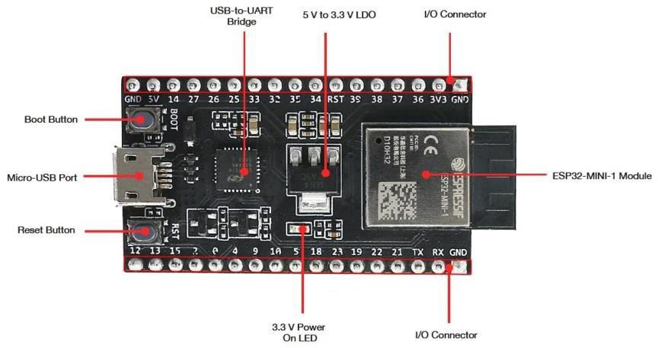

Fig 3.1.1 : ESP32

3.1.2 IR RECEIVER

An Infrared (IR) receiver is an electronic component designed to detect and decode infrared signals transmitted by remote controls, sensors, or other IR- emitting devices. It plays a crucial role in various applications, from consumer electronics like TVs and air conditioners to industrial automation and security systems. Here's an explanation of IR receivers in five paragraphs receivers work on the principle of detecting and decoding infrared light, which is not visible to the human eye. When an IR-emitting device, like a remote control, sends a command, it transmits a modulated IR signal. The IR receiver's sensor detects this signal, converts it into an electrical voltage, and sends it to the decoding circuit. The decoding circuit processes the signal to extract the command information, such as button presses on a remote control.

An IR receiver typically consists of a few essential components. These include an IR sensor or photodiode, a pre-amplifier, a demodulator, decoding circuit. The IR sensor is the light-sensitive element that detects the incoming IR signal, while the pre-amplifier boosts the weak electrical signal from the sensor.

The demodulator extracts the carrier frequency from the modulate signal, and the decoding circuit interprets the received data based on a specificprotocol, such as NEC or RC-5, which are common standards used for remote controls.
APPLICATIONS:

IR receivers are widely used in various applications. In consumer electronics, they are commonly found in televisions, set-top boxes, DVD players, and air conditioners to receive remote control commands. In industrial settings, IR receivers can be used in automation and robotics, allowing machines to receiveinstructions from a central controller. They also have applications in security systems, where they can be used to detect and respond to specific IR signals, like those from motion detectors or surveillance cameras.One of the most familiar uses of IR receivers is in remote controls. When you press a button on your TV remote, for example, the corresponding command is transmitted as an IR signal. The IR receiver in your TV detects the signal, decodes it, and carries out the associated action, like changing the channel or adjusting the volume. This technology has become an integral part of our daily lives, offering convenience and ease of control for a wide range of electronic devices.

3.1.3 GPS TRACKER:

GPS tracking technology has become the most popular choice for making transportation businesses highly productive. GPS allows you to track the location of your vehicles, find out the time and thus the cost per delivery, and allow you to optimise deliveries based on daily and weekly patterns that you see in traffic.

A GPS tracker is a device that uses the Global Positioning System (GPS) to determine the precise location of an object or person. These trackers can be used for various purposes, such as tracking the location of vehicles, monitoring the whereabouts of people, or even keeping tabs on valuable assets. They work by receiving signals from GPS satellites and then transmitting the location data to a central server or a user's device, allowing real-time tracking and location history. GPS trackers are commonly used for fleet management, personal safety, and asset tracking.
3.1.4 ESP32-MINI-1 MODULE:

The ESP32 chip features 34 physical GPIO pins (GPIO0 ~ GPIO19, GPIO21
~ GPIO23, GPIO25 ~ GPIO27, and GPIO32 ~ GPIO39). Each pin can be used as a general-purpose I/O, or be connected to an internal peripheral signal.

All ESP32 Series of modules have a wide operating temperature range of - 40°C to 105°C, and are suitable for commercial application development with a robust 4- layer design that is fully compliant with FCC, CE-RED, SRRC, IC, KCC & TELEC standard. A micro-USB cable is when you need to power up or program your ESP32 module or a Raspberry Pi 3. This micro-USB cable can replace your old mobile charger wire too! Buy online in India the Micro USB cable for ESP32 or Raspberry Pi
3 with fast shipping at Circuit Uncle.

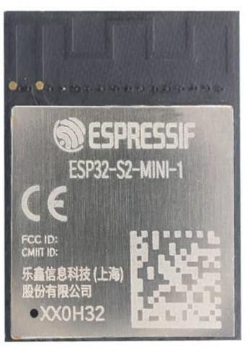

FIG 3.1.2 : ESP32-MINI-1 MODULE

The ESP32 Mini-1 module is a compact and powerful Wi-Fi and Bluetooth module based on the ESP32 chipset, which is developed by expressive Systems. It offers a wide range of features for IoT (Internet of Things) applications, including built-in Wi-Fi and Bluetooth connectivity, GPIO pins for interfacing with various sensors and devices, and support for various communication protocols.
3.2 SOFTWARE DESCRIPTION:

3.2.1 ARDIUNO IDE

Arduino IDE can be implemented within Windows (11, 10, 8.1, 8, 7), Mac and Linux operating systems. The majority of its components are written in JavaScript for easy editing and compiling. While its primary intention is based around writing codes, there are several other features worth noting. It has been equipped with a means to easily share any details with other project stakeholders. Users can modify internal layouts and schematics when required. There are in-depth help guides which will prove useful during the initial installation process. Tutorials are likewise available for those who might not have a substantial amount of experience with the Arduino frame work.

Node-RED is an open-source flow-based development tool for visual programming. It is often used for IoT (Internet of Things) and other automation and integration tasks. Here are some key aspects of Node-RED: Flow-Based Programming: Node-RED uses a flow-based programming paradigm. In this approach, you create applications by connecting nodes together, each representing a specific function or service.

FUNCTIONS AND USES

Arduino IDE can be implemented within Windows (11, 10, 8.1, 8, 7), Mac and Linux operating systems. The majority of its components are written in JavaScript for easy editing and compiling. While its primary intention is based around writing codes, there are several other features worth noting. It has been equipped with a means to easily share any details with other project stakeholders. Users can modify internal layouts and schematics when required. There are in-depth help guides which will prove useful during the initial installation process. Tutorials are likewise available for those who might not have a substantial amount of experience with the Arduino frame work.
3.2.2 NODE RED

Node-RED is an open-source flow-based development tool for visual programming. It is often used for IoT (Internet of Things) and other automation and integration tasks. Here are some key aspects of Node-RED: Flow-Based Programming: Node-RED uses a flow-based programming paradigm. In this approach, you create applications by connecting nodes together, each representing a specific function or service. These nodes are arranged in an integrating web service and database.
CHAPTER-4

CIRCUIT OF THE PROPESED METHOD

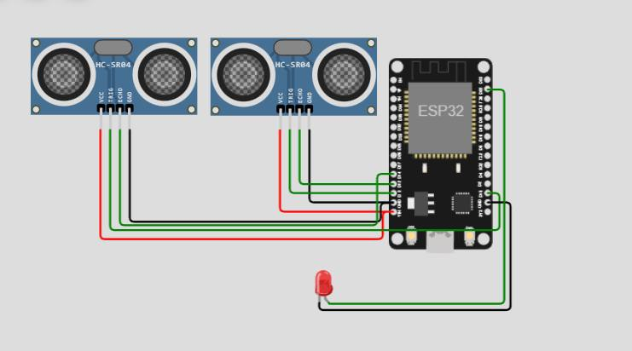

4.1 WORKING
FIG 4.1 : CIRCUIT DIAGRAM

Public transportation optimization using an ESP32, ultrasonic sensors, IR (Infrared) sensors, and a GPS tracker involves the integration of these components to create a smart transportation system. The ESP32 serves as the central processing unit inthis setup. It is responsible for collecting, processing, and transmitting data fromthe various sensors and components. It can also communicate with a central server or control centre through Wi-Fi or other communication protocols. Ultrasonic sensors are used to monitor the distance between the transportation vehicle (e.g., a bus) and nearby objects, such as other vehicles or pedestrians. This data helps in collision avoidance and maintaining a safe distance. Infrared sensors can be employed to detect the presence of passengers when they board or disembark from the vehicle. This data is crucial for monitoring passenger counts and optimizing routes based on demand. A GPS tracker on the vehicle provides real-time location information. This data can be used for tracking the vehicle's position, ensuring it follows the designated route, and estimating arrival times at various stops.
Here's how these components work together:

The ESP32 constantly collects data from the ultrasonic sensors, IR sensors, and GPS tracker. Ultrasonic sensors measure distances, and if an object is too close, the ESP32 can trigger alerts to the driver or central control centre to prevent collisions. IR sensors detect passenger boarding and disembarking, allowing the system to update passenger counts. The GPS tracker provides real-time location information, which can be used to track the vehicle and optimize routes. Algorithms can analyse this data to make real-time decisions, such as rerouting a bus to avoid traffic congestion. Data from these sensors can be transmitted to a central server or a cloud-based platform using Wi-Fi or other communication methods. This data is then processed and analysed. Advanced algorithms and machine learning models can be applied to the collected data for various purposes, such as route optimization, predictive maintenance (identifying issues with the vehicle before they become critical), and passenger information (providing real-time updates on bus locations and estimated arrival times). Passengers can access this information through mobile apps or digital displays at bus stops, improving their travel experience. Transportation authorities can make informed decisions about route adjustments, maintenance scheduling, and resource allocation, leading to more efficient and cost-effective public transportation. In summary, the combination of ESP32, ultrasonic sensors, IR sensors, and GPS tracking creates an intelligent public transportation system that enhances safety, efficiency, and the overall passenger experience while enabling authorities to make data-driven decisions for optimization.

CODE

#define BLYNK_TEMPLATE_ID "TMPL26V4fGv5q"
#define BLYNK_TEMPLATE_NAME "Test"
#define BLYNK_AUTH_TOKEN "XEHxNF_Ur1Nt2p7wB5B20dNI1ZUwj34P"

#include <WiFi.h>
#include <WiFiClient.h>
#include <BlynkSimpleEsp32.h>

int duration1 = 0; int distance1 = 0; int duration2 = 0; int distance2 = 0; int dis1 = 0;
int dis2 = 0;
int dis_new1 = 0; int dis_new2 = 0; int entered = 0; int left = 0;
int inside = 0;
#define LED 2
#define PIN_TRIG1 15
#define PIN_ECHO1 14
#define PIN_TRIG2 13
#define PIN_ECHO2 12
BlynkTimer timer;

char auth[] = BLYNK_AUTH_TOKEN;
char ssid[] = "Wokwi-GUEST"; // your network SSID (name)
char pass[] = "";
#define BLYNK_PRINT Serial

long get_distance1() {
// Start a new measurement: digitalWrite(PIN_TRIG1, HIGH); delayMicroseconds(10);
digitalWrite(PIN_TRIG1, LOW);

// Read the result:
duration1 = pulseIn(PIN_ECHO1, HIGH);
distance1 = duration1 / 58;
return distance1;
}

long get_distance2() {
// Start a new measurement: digitalWrite(PIN_TRIG2, HIGH); delayMicroseconds(10);
digitalWrite(PIN_TRIG2, LOW);

// Read the result:
duration2 = pulseIn(PIN_ECHO2, HIGH);
distance2 = duration2 / 58;
return distance2;
}

void myTimer() { Serial.println("100"); dis_new1 = get_distance1(); dis_new2 = get_distance2();
if (dis1 != dis_new1 || dis2 != dis_new2){
Serial.println("200");
if (dis1 < dis2){ Serial.println("Enter loop"); entered = entered + 1;
inside = inside + 1; digitalWrite(LED, HIGH); Blynk.virtualWrite(V0, entered); Blynk.virtualWrite(V2, inside); dis1 = dis_new1;
delay(1000);
digitalWrite(LED, LOW);
}
if (dis1 > dis2){ Serial.println("Leave loop"); left = left + 1;
inside = inside - 1; Blynk.virtualWrite(V1, left); Blynk.virtualWrite(V2, inside); dis2 = dis_new2;
delay(1000);
}

}

}

void setup() { Serial.begin(115200); pinMode(LED, OUTPUT); pinMode(PIN_TRIG1, OUTPUT); pinMode(PIN_ECHO1, INPUT); pinMode(PIN_TRIG2, OUTPUT); pinMode(PIN_ECHO2, INPUT);
Blynk.begin(auth, ssid, pass, "blynk.cloud", 8080);
timer.setInterval(1000L, myTimer);

}

void loop() { Blynk.run(); timer.run();
}
CHAPTER-5

RESULT

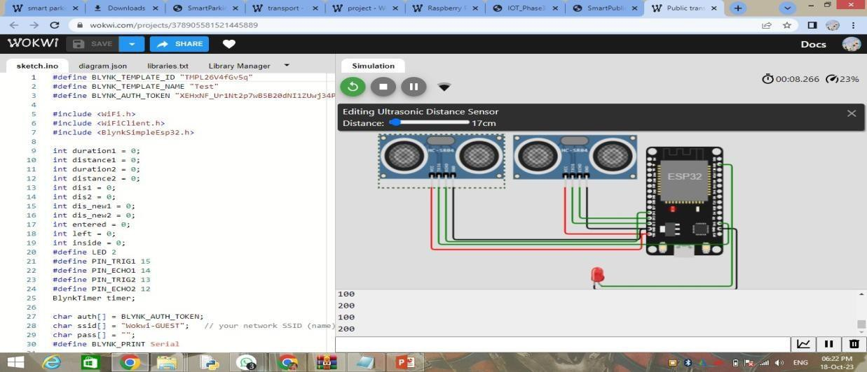

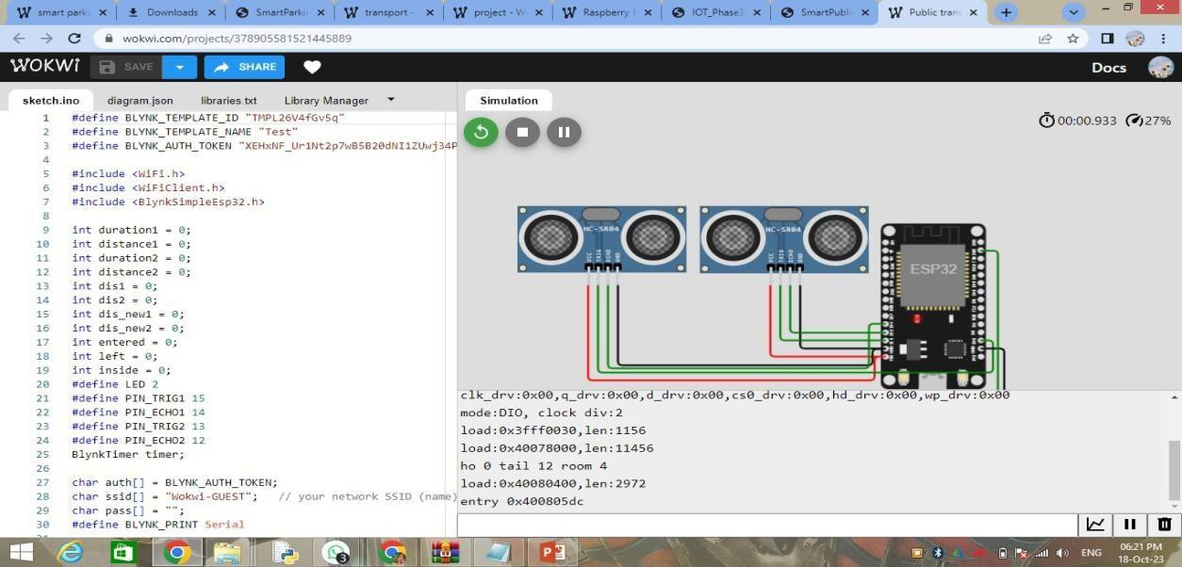

SIMULATION LINK: https://wokwi.com/projects/378905581521445889
5.1ADVANTAGES

Public transportation optimization offers a wide range of advantages, making it a crucial element of sustainable urban mobility and transportation systems. Here are some key advantages:

1. Reduced Traffic Congestion: Efficient public transportation systems can alleviate road congestion by reducing the number of private vehicles on the road. This leads to smoother traffic flow, shorter travel times, and decreased stress forcommuters.

2. Environmental Benefits: Public transportation optimization can significantly reduce greenhouse gas emissions. By promoting the use of buses, trams, subways, and other forms of mass transit, it helps mitigate air pollution and decrease the carbon footprint of urban areas.

3. Energy Efficiency: Public transportation is generally more energy-efficient per passenger mile compared to private vehicles. Optimizing routes and using modern, energy-efficient vehicles can further improve energy conservation.

4. Economic Savings: It can be cost-effective for both governments and individuals. Public transportation is often more affordable than owning and maintaining a private vehicle, and it can reduce overall transportation costs for individuals and families.

5. Access to Opportunities: Public transportation expands access to education, jobs, healthcare, and other essential services, particularly for those who may not have access to private vehicles. This improves social equity and economic opportunities.

6.Reduced Parking Demand: Efficient public transportation systems reduce the need for extensive parking infrastructure, freeing up valuable urban space for other purposes and reducing the burden on city budgets.

In conclusion, public transportation optimization not only provides numerous benefits for the environment, the economy, and society but also plays a vital role in shaping more sustainable and livable cities for the future.
5.2 LIMITATIONS OF PUBLIC TRANSPORTATIONOPTIMIZATION

Public transportation optimization, while offering numerous benefits, also comes with certain limitations. One significant challenge is the need for substantial initial investments in infrastructure and technology. Upgrading or expanding public transportation systems often requires substantial funding and time, making it a long- term commitment for municipalities and governments. Additionally, adapting existing infrastructure to accommodate new technologies can be complex and disruptive. Another limitation is the potential resistance to change from the public, as people may be hesitant to shift from their personal vehicles to public transportation, even if it's more efficient. Furthermore, maintenance and operational costs can be substantial, and fare collection and revenue generation may not always cover these expenses. Lastly, public transportation optimization may face geographical limitations, with rural and less densely populated areas finding it challenging to implement efficient systems. Overcoming these limitations requires careful planning, investment, and community engagement to ensure the success of public transportation optimization efforts.

5.3APPLICATIONS OF PUBLIC TRANSPORTATIONOPTIMIZATION.

Public transportation optimization finds extensive application in enhancing urban mobility and transforming the way people move within cities. It plays a pivotal role in reducing traffic congestion by offering efficient alternatives to private vehicle use, thereby easing the strain on road infrastructure. This technology is crucial in promoting sustainable urban development and reducing environmental impacts by decreasing emissions and air pollution. Furthermore, it improves access to essential services, such as healthcare, education, and employment, particularly for underserved communities, contributing to social equity and economic growth. Public transportation optimization also supports economic savings for both individuals and municipalities, as it can be more cost- effective than car ownership, reducing the burden on city budgets and promoting efficient resource utilization. Moreover, by integrating data-driven decision- making and smart technologies, it aligns with the principles of smart cities, making urban areas more livable and responsive to the needs of their residents.
CHAPTER-6

FUTURE SCOPE

The future of public transportation optimization holds great promise, with several exciting scopes and potential developments on the horizon. As cities continue to grow, there is an increasing need for more efficient, sustainable, and accessible transportation solutions. Emerging technologies, such as autonomous vehicles and electric buses, will likely play a significant role in shaping the future of public transportation. These advancements have the potential to improve safetyand efficiency while reducing emissions and operational costs. Overall, the future of public transportation optimization holds the potential for more efficient, sustainable, and passenger-centric systems that can address the growing demands of urbanization and contribute to the development of smarter, more livable cities.

6.1 CONCLUSION

In conclusion, public transportation optimization represents a pivotal solution to the evolving transportation needs of our increasingly urbanized world. It not only addresses the challenges of traffic congestion, environmental sustainability, and economic efficiency but also fosters accessible and inclusive mobility for diverse communities. By harnessing advanced technologies, data- driven decision-making, and a commitment to improving the passenger experience, public transportation optimization has the potential to shape the future of urban mobility. As we look ahead, this field will continue to drive innovations in route optimization, vehicle electrification, and multi-modal integration, ultimately contributing to more sustainable and livable cities. The ongoing development and expansion of optimized public transportation systems offer a pathway toward a cleaner, more efficient, and more equitable future for transportation, making urban life more convenient and environmentallyresponsible.

